**GET OUT!!!**

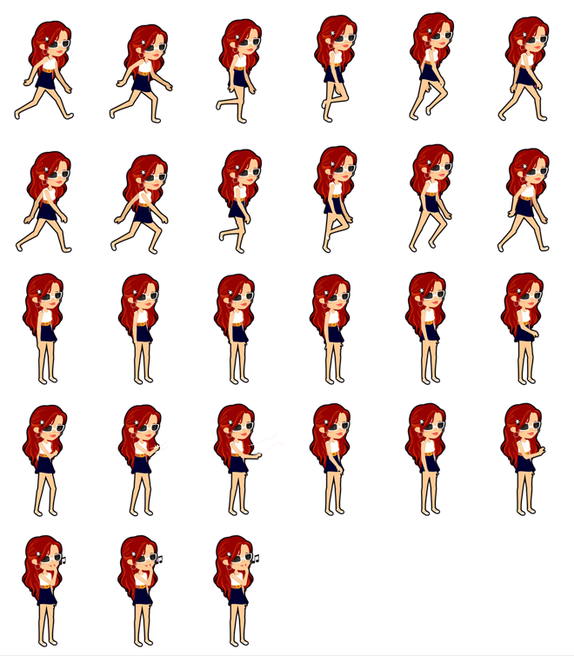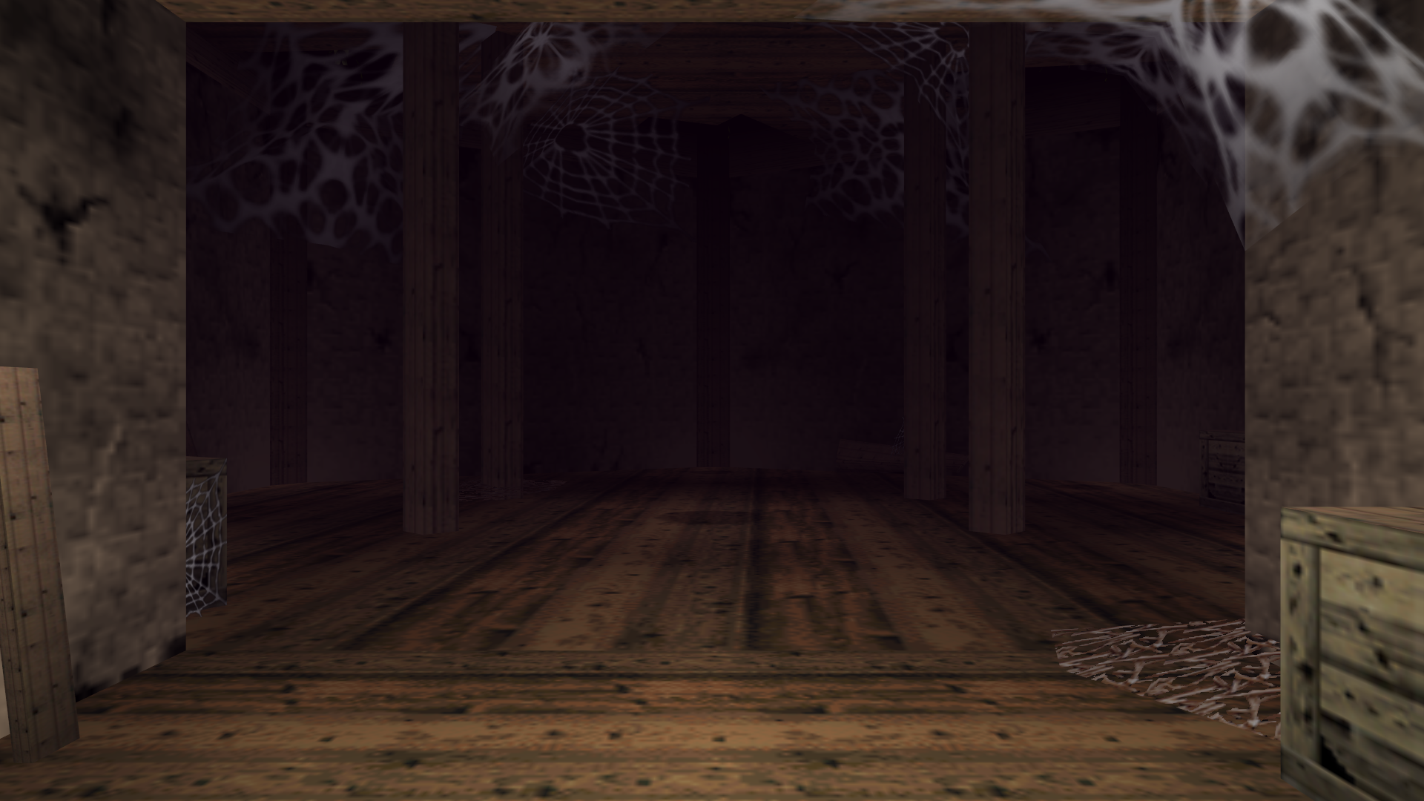

Almighty Tech

Kelly F, Arianna C, Camron B

<Image of Each Level>

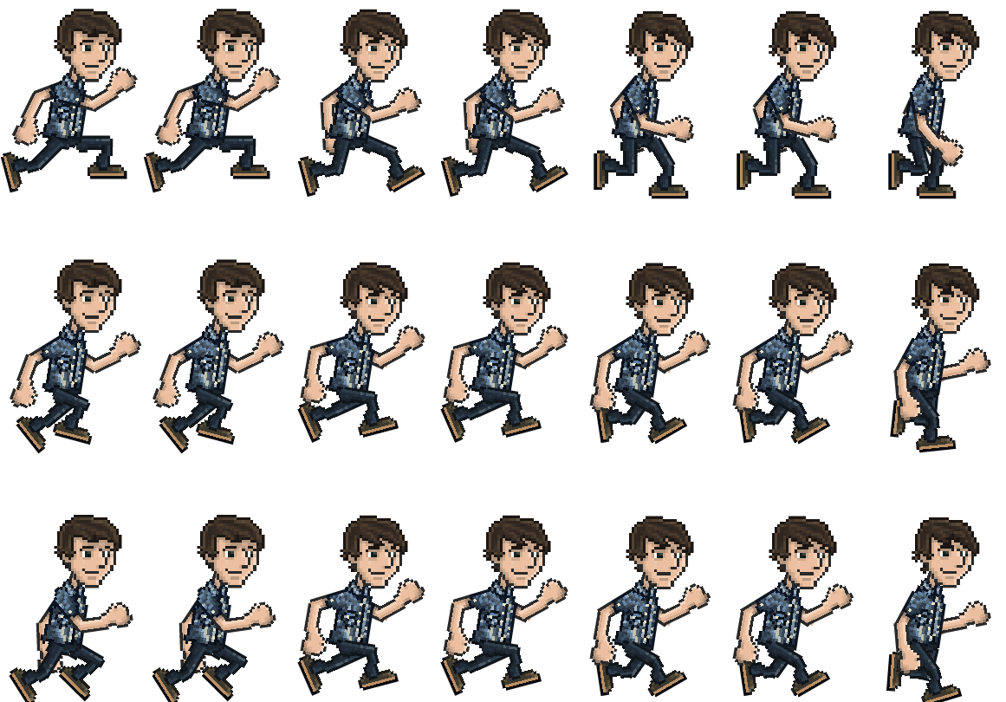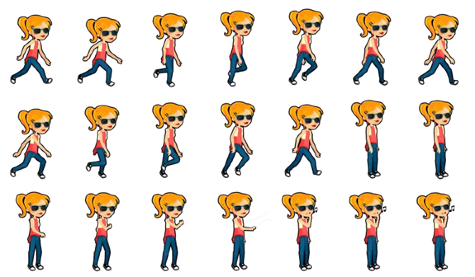

**Algorithm**

**Import gamelib**

**Create a variable for the Game object:** The objective of the game is to get through each room and try not to get touched by ghosts. Also try to collect notes and letters to get hints to try to help you escape the haunted house.

**Create variables for graphics:**

**Create a variable for the font**

**Create 4 sound variables.**

**Create an start screen:**

**Add the game loop**

**Add the ending Screen:** The end screen will be the 3 characters finally escaping the haunted house if you’re lucky.